Shikhar Giri

TARGET MARKET:

I designed my cereal box focusing from kids to the adults. Mainly help all the families who are looking for healthier breakfast option. My distributors will be the Kroger, HEB & Walmart along with online shopping merchant.

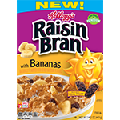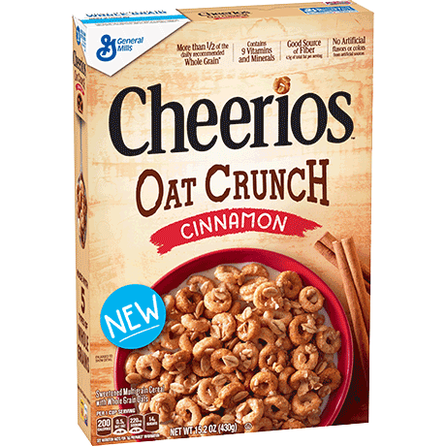

COMPETITION RESEARCH:  
With a motto of providing healthier snacks option for families, my competition were Cheerios Oat Crunch and Kellogg’s Raisin Bran Cereal. Cheerios Oat Crunch is manufactured by the General Mills which was launched for American homes in 1941. (2011) Kellogg’s Raisin Bran Cereal is manufactured by Kellogg’s which was established in 1906 by Kellogg and his brother. Kellogg’s claims that after they started the invention of cereal, they have changed the way we eat breakfast after then. (2014)

Researchers of these giant company believes that the quality and the healthier cereal is most important to the consumer. It is basically important to build a trust up to the consumers, so they are interested in trying them and like it after that. (2014)

Cheerios manufactured by General Mills as well as the Kellogg’s claims that all the food they produced are 100% organic and USDA approved. It has basically changed the overall way of eating breakfast after such companies are in market.

I believe that for a food product, the quality of the product is most but also the packaging matters while it about the marketing. As we know everybody likes the organic products. So, the final finishing of the package determines the visuality along with it reflects the quality of the product towards the consumer.

So, in my design looking over the quality stuff, I have considered the Organic and USDA Approved sticker to be used.

Research References:

Cheerios Oat Crunch. (2017) (n.d.). Retrieved September 12, 2018, from <https://www.cheerios.com/products/cheerios-oat-crunch/>

General Mills: Purpose. (2011) (n.d.). Retrieved from <https://www.generalmills.com/en/Company/purpose>

Making Food People Love. (n.d.). Retrieved from <https://history.generalmills.com/the-video.html>

About Kellogg Company. (2014) (n.d.). Retrieved from <https://www.kelloggcompany.com/en_US/our-vision-purpose.html>

Kellogg's Raisin Bran Cereal. (n.d.). Retrieved from <https://www.kelloggs.com/en_US/products/raisin-bran-banana.html>

ANALYTICAL REASONGING:

Most of the designing this cereal box, I have been using the pen tools and color swatches a lot. It helps all the way from tracing the scathes and helps to change the edges using anchor point. This has been useful at all. Color swatches helped while using a lot of colors in the box.

I find that the labelling a layer is good idea because it helps in find the layers immediately when needed.

There is some condition when the layers are overlapped and also when we use photos to trace out, it helps a lot by using the outline tools in such case.

As we talked about the quality of the product is compulsory, the quality designing also plays important role to influence the consumer to buy the certain product.